NRA Basic Pistol / Personal Protection

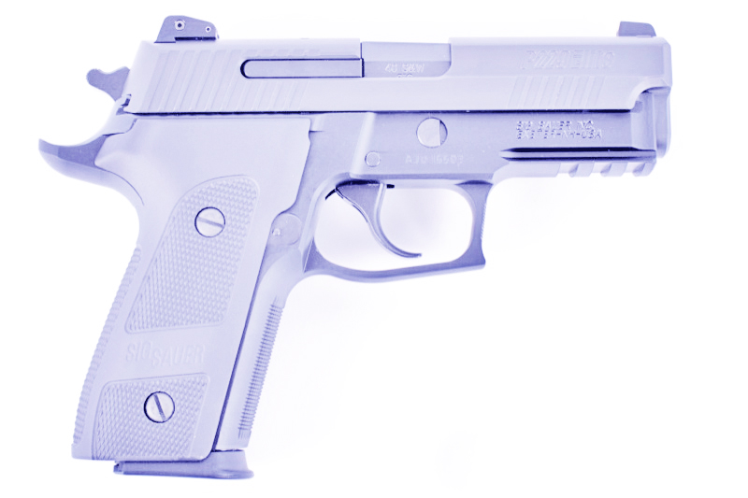
A Combo class designed for BEGINNERS and those having little or no firearms training.
Designed around the instructional needs and concerns of women.
Presented by: The Detroit Sportsmen’s Congress
48900 Dequindre, Shelby Township, MI 48317 Phone: 586-739-3500

Certified NRA & MCRGO Instructors and a local Attorney will teach this course. It will review all of the Fundamentals as well as practical range experience in proper handling, aiming, and shooting of a handgun. One-on-one range instruction. Citizen’s rights and responsibilities as it pertains to firearms will be addressed. State Laws pertaining to purchase, transport, and concealed carry will be taught. Class attendance will earn NRA and CPL certificates.

COURSE OBJECTIVES:
Handgun Knowledge and Safe Gun Handling
Ammunition, Storage, Cleaning, and Child Safety
Fundamentals and Practical Range Handgun Shooting Exercises
Firearms and The Law -Includes CPL Certification
Basic Pistol and Principles of Personal Protection in the Home

TIMES AND DATES: (This Is A Five Class Course)
June 02, 2024 Basic Pistol 1 & 2 from 8:30 am to 4:30 pm
Detroit Sportsmen’s Congress Clubhouse
June 03, 04, 10 CPL Class from 7:00 pm to 10:30 pm
Detroit Sportsmen’s Congress Range Building

COST: $250.00 All Classroom and Shooting Material Provided for both Classes
DSC Members cost is $220.00

TO REGISTER: (PRE-REGISTRATION IS REQUIRED. CLASS SIZE IS LIMITED)
RETURN OR EMAIL THE FORM TO ADDRESS BELOW, PAYMENT DUE AT FIRST CLASS
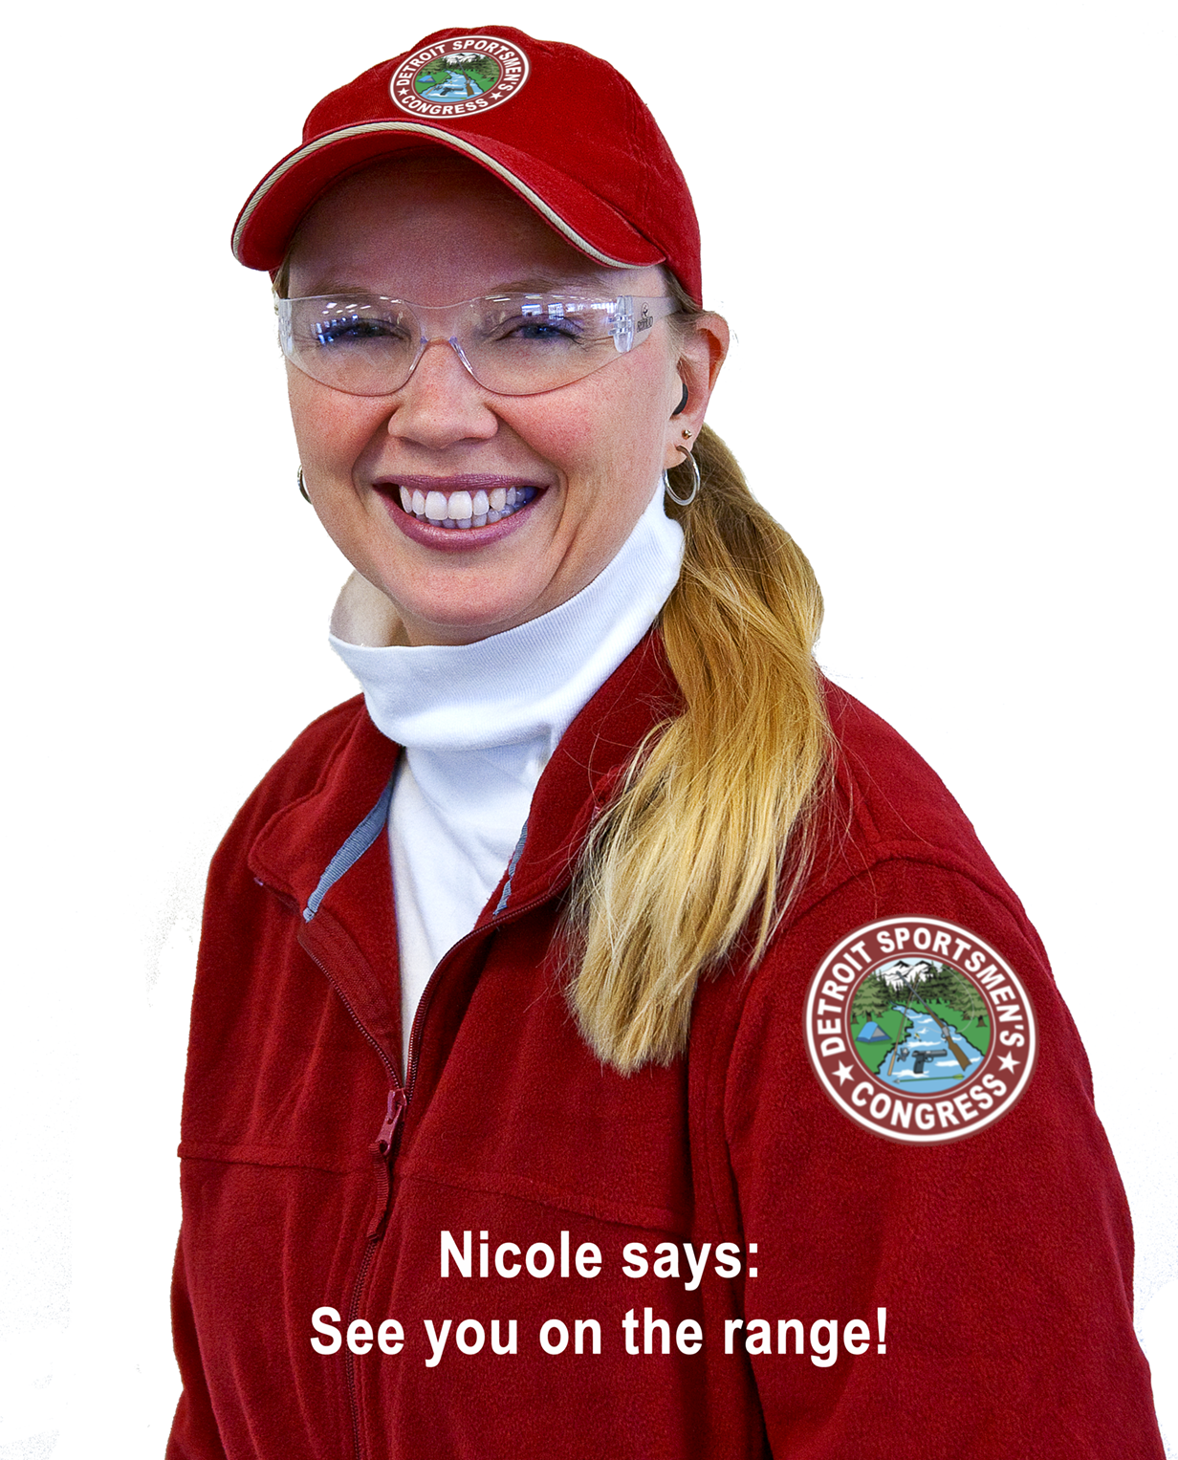
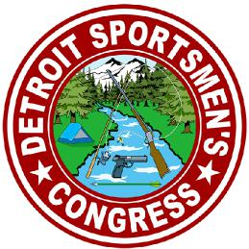
Enter your name as it appears on your driver’s license or state ID
June 02,03,04,10, 2024
Return form to:
Bob Savo
53741 Tidal Lane Phone: 248-651-8667
Shelby Twp., MI 48316 Email: rmsavo@ameritech.net

Name:
Address:
City: | State: | Zip:
Phone: | DSC No.
Email:

You must be 21 or older

